Hi Aleks and Anna, here are the instructions/details for the Ronson minisite –

**We will start with the homepage (desktop first) and slowly send the rest of the pages and mobile versions.**

**This project is heavily based on the original polish website** [**http://ronson.pl/en/**](http://ronson.pl/en/)

**Please look at it while working as it can save you some time.**

**General**

* Font used (attached) is called “Heebo”
* The text fields mean, from right to left – name > phone number > email
* The form should send the lead information to [office@ronson.co.il](mailto:office@ronson.co.il) with the title

**"פניה מדף הבית של רונסון ישראל"**

* Button default color - #e42a37
* Button hover color - #c11b27

**Navigation strip**

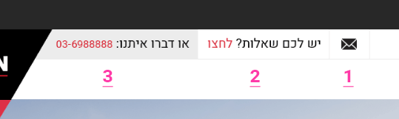

* 1 Should open the mail client with a mail to [office@ronson.co.il](mailto:office@ronson.co.il) with the subject

**"פניה מדף הבית של רונסון ישראל"**

* 2 should open the floating form – see group “Floating form” in PSD
* 3 should call the shown number.
* **All the rest of the navigation links should have placeholder links for now.**

**Intro section**

* The 5 projects strip is taken straight from Polish website – please take 5 projects from there and embed in our page – **no slider please**
* Below the projects is a video - <https://we.tl/BigfO4ODD7>

**Steps section**

* Buttons will lead to sections on upcoming “How” page. Placeholder links for now

**Footer**

* Left button should call number
* Right button should open “Floating form”

Thanks and good luck!